**E-Ticket**

**A Minor Project Synopsis Submitted to**



**Rajiv Gandhi Proudyogiki Vishwavidyalaya, Bhopal**

**Towards Partial Fulfillment for the Award of**

**Bachelor of Technology**

**(Computer Science and Engineering)**

**Submitted By**

**Abhay Gour (0827CS201009) Aarohi Rathore (0827CS201004)**

**Aayush Gupta (0827CS201006)**

**Ankur Nagar (0827CS201035)**

**Under the Supervision of**

**Prof. Priyanka Jangde**



**Department of Computer Science and Engineering**

**Acropolis Institute of Technology & Research, Indore**

**July-Dec 2022**

# Abstract

The paper describes the opportunities and challenges of e-ticketing in most of the board system like public transportation, museums heritage sites and so on. While the concept of eticketing is prevalent in the museums, entrance boards, heritage sites it is difficult to implement in an operating environment where the entire business strategy is based on an “open access” system for flexible travelling. Here we devise a QR based ticketing system with necessary hardware for the seamless visitor experience in Museums/Heritage sites along with a best Facial recognition based ticket generation. In addition, The prediction of the expected crowd will be added as a feature.

# Introduction of the Project

E-ticketing in tourism as a “paperless” revolution, first hit US based airlines in the 80s. It was used primarily by domestic carriers operating point to point flights. But once it got started, the travel industry globally saw the opportunity for a dramatic transformation in ticketing systems. E-ticketing is a method for documenting sale, tracking usage and accounting for a passenger's visiting without requiring the issue of paper “value documents”. Passengers are able to book, pay for and print their e-tickets online from any point in the world and explore the historical places.

# Objective

Unless like in the previous stage people as to walk into monument ticket counters to buy the tickets and also to check the timings. This problem is overcome introducing Online Ticket Booking System. This project will provide an option to customers to book the tickets online and to check the confirmation online. Using this system customer can book museums/heritage sites ticket so they can enjoy their trip without any suffering of crowd. Additionally the tickets made at offline points will be based on facial recognition and no man- work required to check the tickets.

# Scope

The project objective is to book tickets in online for visiting museums/heritage sites.. The E-Ticket Reservation System is an Internet based application that can be accessed throughout the Net and can be accessed by anyone who has a net connection. This application will reserve the tickets. This online ticket reservation system provides a website for a for visit museums/heritage sites where any user of internet can access it. User is required to login to the system and needs a credit card for booking the tickets. Tickets can be collected at the counter and exploring the historical sites and places with family and friends . In museums/heritage sites is one of the best medium of enjoyment after having a hectic schedule. But all this excitement vanishes after standing in hours in long queues to get tickets booked. The website provides complete information regarding currently how many people are already in museums/heritage sites or how many people are in waiting. Ticket reservations are done using credit card and can be cancelled if needed. Our online tickets reservation system is one of the best opportunities for those who cannot afford enough time to get their tickets reserved standing in long queues. People can book tickets online at any time of day or night. Our reservation system also provides option to cancel the tickets which are reserved previously.

# Study of Existing Systems:

Existing system refers to the system that is being followed till now. The existing system requires more computational time, more manual calculations, and the complexity involved in Selection of features is high. The other disadvantages are lack of security of data, Deficiency of Data accuracy, Time consuming etc. To avoid all these limitations and make the working more accurately the system needs to be computerized. Here in the E-ticketing, a detailed study of existing system is carried along with all the steps in system analysis.

# 5.1 Drawbacks Of Existing System:

Here in the E-ticketing, a detailed study of existing system is carried along with all

the steps in system analysis. An idea for creating a better project was carried and the next steps were followed.

* Lack of security of data.
* More man power.
* Time consuming.
* Consumes large volume of pare work.
* Needs manual calculations.
* No direct role for the higher officials.
* Damage of machines due to lack of attention.

To avoid all these limitations and make the working more accurately the system needs to be computerized.

# 5.2 Proposed System:

The aim of proposed system is to develop a system of improved facilities. The proposed system can overcome all the limitations of the existing system. The system provides proper security and reduces the manual work. The existing system has several disadvantages and many more difficulties to work well. The proposed system tries to eliminate or reduce these difficulties up to some extent. The proposed system will help the user to reduce the workload and mental conflict. The proposed system helps the user to work user friendly and he can easily do his jobs without time lagging.

# 5.3 Advantages Of Proposed System:

The system is very simple in design and to implement. The system requires very low system resources and the system will work in almost all configurations. It has got following features :

* Ensure data accuracy.
* Minimize manual data entry.
* Minimum time needed for the various processing
* Greater efficiency

# Project Description:

As the study is expanding and having many customers, it faces different problems. With these problems, their system experiences: unorganized transactions, long queue, scammers, unreliable updates about the upcoming events, and the availability of ticket at the ticket store. In the mentioned problems, there are possible solutions that can help the study. The e-ticketing system can help the customers, the company, marketing staffs and other employees of the business. The proposed system has many features that can help every user have a faster and easier process. Every business is being known by its good service. The number of people patronizing this business is rapidly growing with the implementation of the e-ticketing, the customers can have a more secured and assured purchase of tickets. With this idea, the company can offer quality services to the customers and a faster, reliable, accessible, time efficient, effortless and easier process of purchasing tickets.

The proponents decided to make a e-ticketing system to make it more convenient to the business and customers. This will create efficiencies that will provide better ticketing functionality for the customers, potentially reduce vendor fees based on consolidated ticket volume.

# Use-case modules:

**Use-Case Diagram**

The E-ticket system uses the following use cases:

1. Request for seat availability

2. makeReservation

3. Cancellation

4. Check status

5. Print ticket

**Actors involved:**

1) System

2) Customer

**Use-Case Name: Check For Ticket Availability**

The customer can view the available tickets in the database for deciding of which

he wishes to reserve.

**Use-Case Name: Make Reservation**

The customer is allowed to reserve a ticket as he/she requires on the particular

date and time. The user has to provide details such as name, contact number, date, proof name and money transaction details.

**Use-Case Name: Print Ticket**

The user after booking a ticket can print a copy of the ticket reserved. The user

has to provide the details about ticket number for searching in the database and

name for confirming identity.

**Use-Case Name: Cancellation**

The customer can decide to cancel a ticket after the ticket is booked. The customer

has to provide details about ticket for searching and details about him for confirmation of

identity.

**Use-Case Name: Check Status**

The customer can view the status of the reserved tickets.

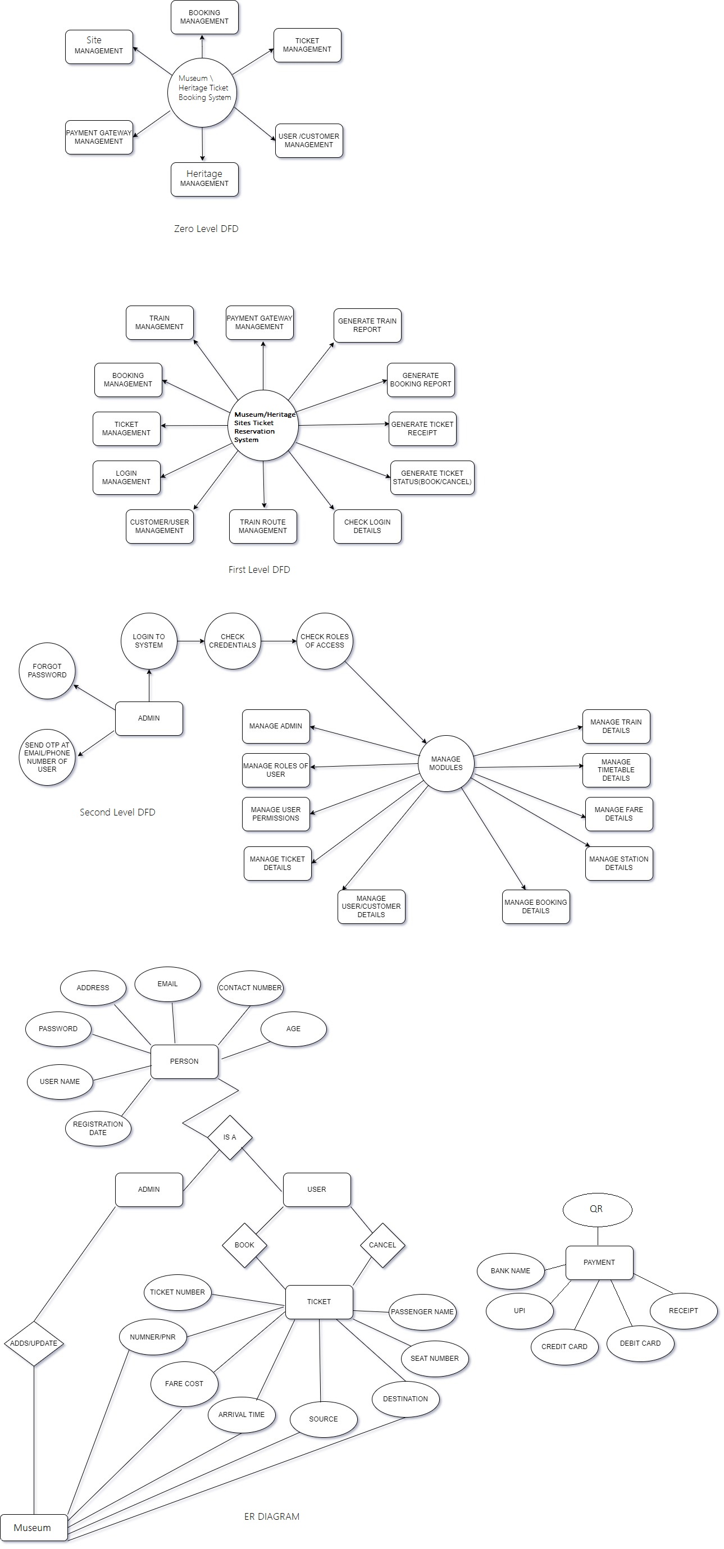







**: ER DIAGRAM FOR E-TICKETING SYSTEM**

# Methodology:

**8.1 Analysis:**

System analysis is a process of gathering and interpreting facts, diagnosing problems and the information to recommend improvements on the system. It is a problem solving activity that requires intensive communication between the system users and system developers. System analysis or study is an important phase of any system development process. The system is studied to the minutest detail and analyzed.

The system analyst plays the role of the interrogator and dwells deep into the working of the present system. The system is viewed as a whole and the input to the system are identified. The outputs from the organizations are traced to the various processes. System analysis is concerned with becoming aware of the problem, identifying the relevant and decisional variables, analyzing and synthesizing the various factors and determining an optimal or at least a satisfactory solution or program of action.

**8.2 Feasibility Study:**

An important outcome of the preliminary investigation is the determination that the system requested is feasible. Feasibility study is carried out to select the best system that meets the performance requirements.

Feasibility study is both necessary and prudent to evaluate the feasibility of the project at the earliest possible time. It involves preliminary investigation of the project and examines whether the designed system will be useful to the organization. Months or years of effort, thousand for millions of money and untold professional embarrassment can be averted if an in-conceived system is recognized early in the definition phase.

**8.3 Logical Design**

The logical flow of a system and define the boundaries of a system. It includes the

following steps:

* Reviews the current physical system – its data flows, file content, volumes,
* frequencies etc.
* Prepares output specifications – that is, determines the format, content and Frequency of
* reports.
* Prepares input specifications – format, content and most of the input functions.
* Prepares edit, security and control specifications.
* Specifies the implementation plan.
* Prepares a logical design walk through of the information flow, output, input, controls and implementation plan.

**8.4 Physical Design**

Physical system produces the working systems by define the design specifications that tell the programmers exactly what the candidate system must do. It includes the following steps:

* Design the physical system.
* Specify input and output media.
* Design the database and specify backup procedures.
* Design physical information flow through the system and a physical design Walk through.
* Plan system implementation.
* Prepare a conversion schedule and target date.
* Determine training procedures, courses and timetable.

**8.5 Database Design**

A database is an organized mechanism that has the capability of storing information through which a user can retrieve stored information in an effective and efficient manner. The data is the purpose of any database and must be protected. The database design is a two level process. In the first step, user requirements are gathered together and a database is designed which will meet these requirements as clearly as possible. This step is called Information Level Design and it is taken independent of any individual Database Management System (DBMS).

# Expected Outcome:

* E-Ticket Booking System project is aimed to provides facility to book tickets anytime and from anywhere.
* One objective of this project is to minimize the number of staff at the ticket box window.
* Promote tourism over the internet and gain maximumprofit.
* Provide a 24×7 service to the customer

Up till now all the activities of the ticket booking are performed manually, it requires more human efforts to manage the each and every aspects of organization which is very costly process. To overcome allkind of problems being faced by ticket booking process our project “E-Ticket Booking System” will provide efficient and cost effective solution and always have possibilities of enhancement up any legal extent to satisfy user requirement.

The Project “E-Ticket Booking System” is generalized software and can be easily used anywhere with little or no change.The Changes in software can be easily accommodated. The additionand deletion of the modules in software can be easily adjusted.

# Resources and Limitations

In order for online ticketing strategy to take off internationally, it is necessary for an international Online Ticket Standard (UIC 918.3) to exist. The main drivers pushing for this standard are the German, Swiss and the Belgium railways, museums and heritage sites. The highlights are the interoperability of ticketing control and security. Finalised last year in November, this international standard will be aiming for 2D Barcode containing all necessary travel information. It will include a basic/standard train ticket and additional data of an electronic ticket. Other processes to be complied would be that of digital signature checking and the exchange of control data.

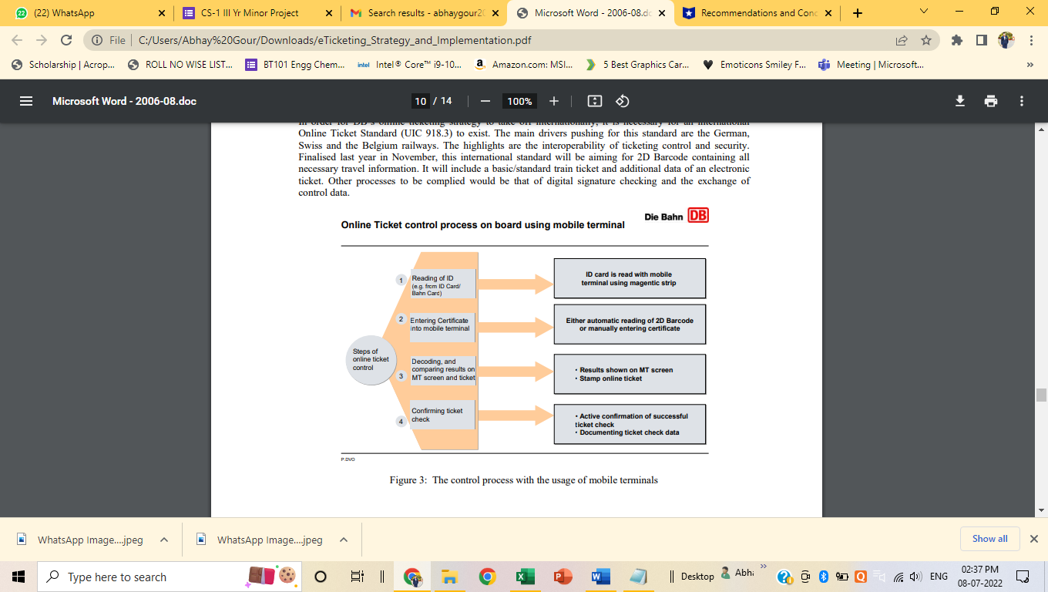

The power of e-ticketing system transportation relies on GPRS (Global Packet Radio Service) and ETM (electronic ticket machines.). Other areas to apply the technology are e-shopping, concert entrances, and sporting concerts.

GPRS is a technology that allows you to complete direct money transfers between the passenger and the business owners. You could be a solo entrepreneur or transport shareholders. Where the transfer entails many shareholders, a central unit facilitates electronic fare transactions.

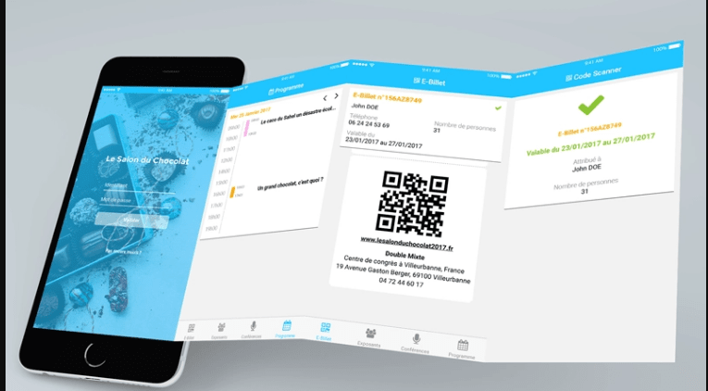

ETMs are the actual tools that collect passenger and ticket details. Currently, a passenger is given a rechargeable smartcard for payments. He or she swipes the card in the machine during payments.

If talked about limitations e-tickets are relatively few; however, if you are less technologically savvy or don't use computers and email, you may find the online ticket purchasing system confusing. You may accidentally delete the email containing your e-ticket or it may get lost among the many messages flooding your inbox. E-tickets also take away some of the personalization of gifting a plane ticket to a friend or loved one.

**11. Conclusion:**

Online ticket booking system is an application where the customer can book a ticket online and 24*7 hours a day from anyplace in the world. Customers can also interact with the ticket booking website to know any other details they want. Online ticket booking system hasbeen developed successfully. System performance is also found to be satisfactory. This is a user-friendly application. Through this application, the cost can be reduced and efficiency is increased. There are several procedures that can be selected by customers. With the help of this application customers can book tickets, can know the status of the Queue in museums, waiting time, Offers on revisiting and destination can be chosen according to their choice, can select seats, can choose the time, and pay through the portal after reaching the museums or heritage sites. Thus online ticket booking system target internal and external audiences. Online ticket booking system is very big to maintain but it always provides excellent facilities to accomplish the goal and help to reduce a complex paperwork process through a mobile application. This can be a benefit using online ticket booking system application rather searching on several websites. With the help of online ticket booking system records are maintained and the database is updated with time to time. Through Online ticket booking system,technologies and features have been introduced.